**Sophisticated Software Solutions**

**Appdex Guide and Help Page**

**0 Startup**

1. Right Click on the file “CSE201Project.xml”
2. Select the Ant Build
3. Select Login, User, and the Default Run

**1 Homepage Functionality**

**1.1 Register New User:**

1. Click Log-in/Register on the homepage
2. Click Register
3. Fill the fields with an unused username and password
4. If the username exists, create a new username or close the app and try logging in instead.

**1.2 Valid User Logins:**

1. Click Login/Register
2. Click Login
3. Valid usernames and passwords are stored in the Log-ins.txt file
4. The level of privilege the User has is stored next to its username and password on the right and will automatically apply.
5. If the Username and password and password are not correct try a different combination or create a new account in the registration page.

**1.3** **Filter Apps:**

1. Click on the drop down menu at the top of the window titled “Filter”
2. Choose either IOS or Android to select the version to filter by
3. Return to full list by clicking Full List

**1.4 Sort Apps:**

1. Click on the drop down menu at the top of the window titled “Sort”
2. Choose between Alphabetical Sorting Ascending and Descending and by Prices in ascending and descending order.
3. Default Sort is Alphabetical Descending

**1.5 Request New Apps:**

1. Sign in to a valid account (See section 1.2)
2. Fill in all of the text areas at the top of the homepage which will represent the various fields that will be stored for the app.
3. Version must be filled with either “IOS” or “Android” or the request will not complete.
4. A decimal or integer value is required in the price text box or request will not complete.

**2 Comments**

**2.1 Read Comments:**

1. Sign in to a valid account (See section 1.2)
2. Click “Comments” section at the top of page
3. Select “Read Comments

**2.2 Adding Comments:**

1. Sign in to a valid account (See section 1.2)
2. Click “Comments” section at the top of page
3. Click “Add Comment”
4. The program will then show you a list of all approved submissions such as this:

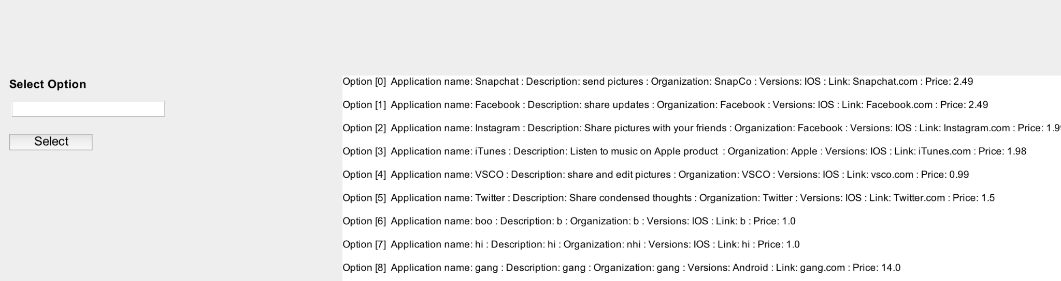

1. Choose the submission that you want to submit your comment on by its respective number, and press ‘Select’
2. Insert you comment and press ‘Add’

**2.3 Deleting Comments:**

1. Sign in to a valid Moderator or Administrator Account (Section 1.2)
2. Click “Comments” section at the top of the window
3. Click “Delete Comment”
4. Select the app from the list by inputting the number from the brackets next to option, ex. Option [0] is 0, into the text field on the left of the interface (Similar to Section 2.2)
5. Click select to view the comments
6. Repeat a process similar to step 4 to delete the comment
7. Choose between weather to continue reading comments or adding comments
8. When done close the window to return to home

**3 App Requests**

**3.1 Approve App Requests:**

1. Create a valid app request (Section 1.5)
2. Sign in to a valid Administrator Account
3. Click “Administrator Board”
4. Click “Go To Admin Board”

-The first application request listed will be the one you are approving.

1. Click “Approve”
2. Unless you were trying to approve another application request, click “Send” to approve the application, and you will return to the HomePage.

**3.2 Decline App Request:**

1. Create a valid app request (Section 1.5)
2. Sign in to a valid Administrator Account
3. Click “Administrator Board”
4. Click “Go To Admin Board”

-The first application request listed will be the one you are approving.

1. Click “Decline”
2. Unless you were trying to approve another application request, click “Send” to approve the application, and you will return to the HomePage

**4 Promoting User/Moderators**

**4.1 Promoting Users to Moderator**

1. Sign in to a valid moderator/administrator account
2. Click “Promotions” at the top of the page
3. Click “Mod Promotion”
4. The program will then show you a list of all current users like this:

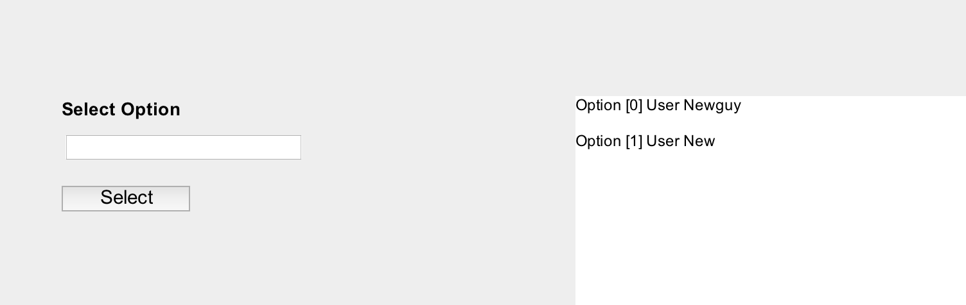

1. Choose the user you want to promote by the number next to the user’s name, and enter it under the “Select Option” box

**4.2 Promoting Moderators to Administrators**

1. Sign in to a valid administrator account
2. Click “Promotions” at the top of the page
3. Click “Admin Promotion”
4. The program will then show you a list of current moderators like this:

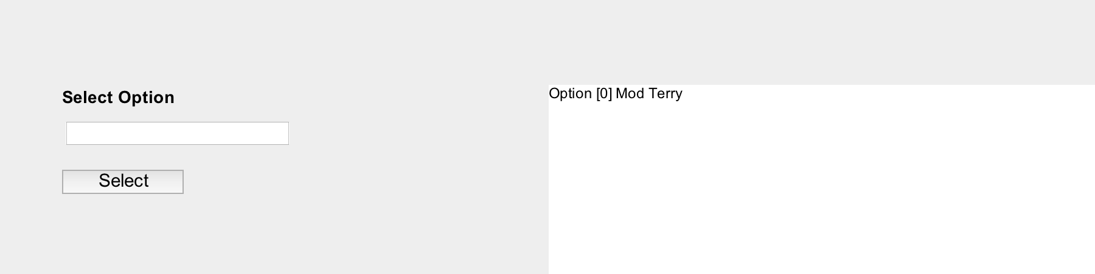

1. Choose the moderator you want to promote by the number next to the user’s name, and enter it under the “Select Option” box.